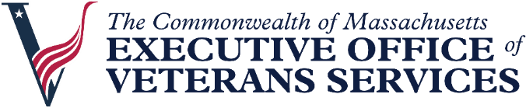
Steward Healthcare Resources for Veterans
In response to the evolving situation with the Steward Healthcare system, the Executive Office of Veterans Services, in partnership with the Department of Public Health and the Department of Veterans Affairs, want to make you aware of alternative options that veterans may be eligible for. Below is information on local VA medical centers, how to apply for VA healthcare, and transportation options to VA facilities.
Mass VA Locations – Locations for all VA Medical Centers, Community Based Outpatient Clinics, and Vet Centers in Massachusetts.
How to Apply for VA Health Care – A step-by-step guide on how to apply for VA healthcare benefits as a veteran or service member and the documents you will need.
Eligibility for VA Health Care – Find out if you are eligible for VA healthcare here.
Income Limits and Your VA Healthcare – Find out if there are income limits that may impact your eligibility for VA healthcare.
Find a Veterans Service Officer Near You - Veterans Service Officers (VSO) are veterans in cities and towns across Massachusetts. Your VSO delivers essential services to eligible veterans and their dependents. Find your local VSO here.
New England VA 1-on-1 Veterans Assistance Expo - Join the Executive Office of Veterans Services at New England's first-ever VA 1-on-1 Veterans Assistance Expo. This event connects service members, veterans, their families, caregivers, and survivors to representatives from the U.S. Department of Veterans Affairs, state, and community partners. Access VA benefits, health care, crisis support, memorial affairs, and peer-to-peer connections all in one place.
Urgent Care and Retail Clinics in Massachusetts - This tool provides a filterable database to help the public find urgent care and retail clinic locations in their community that offer specific services, service times, or accept their insurance type. Urgent care centers and retail clinics are for mild illnesses and minor injuries. If you need emergency medical care, call 911.
DAV Transportation to Veterans - DAV operates a fleet of vehicles around the country to provide free transportation to VA medical facilities for injured and ill veterans. Use the DAV Hospital Service Coordinator Directory to contact your nearest HSC for information or assistance.

EOVS Transportation Resources - Information about transportation services in Massachusetts to help veterans get to medical appointments, jobs, and other destinations.

DPH Health Care Transportation Resources - Transportation services may be available to help you get to local or long-distance medical appointments in Massachusetts. If you, your family member, or your consumers need to get to local or long-distance medical appointments in Massachusetts, some transportation service options may be available.
VA Connected Care - Virtual care is a way that VA physicians and other health care providers, such as nurses, social workers or medical assistants, can communicate with you without physically seeing you in the office.

