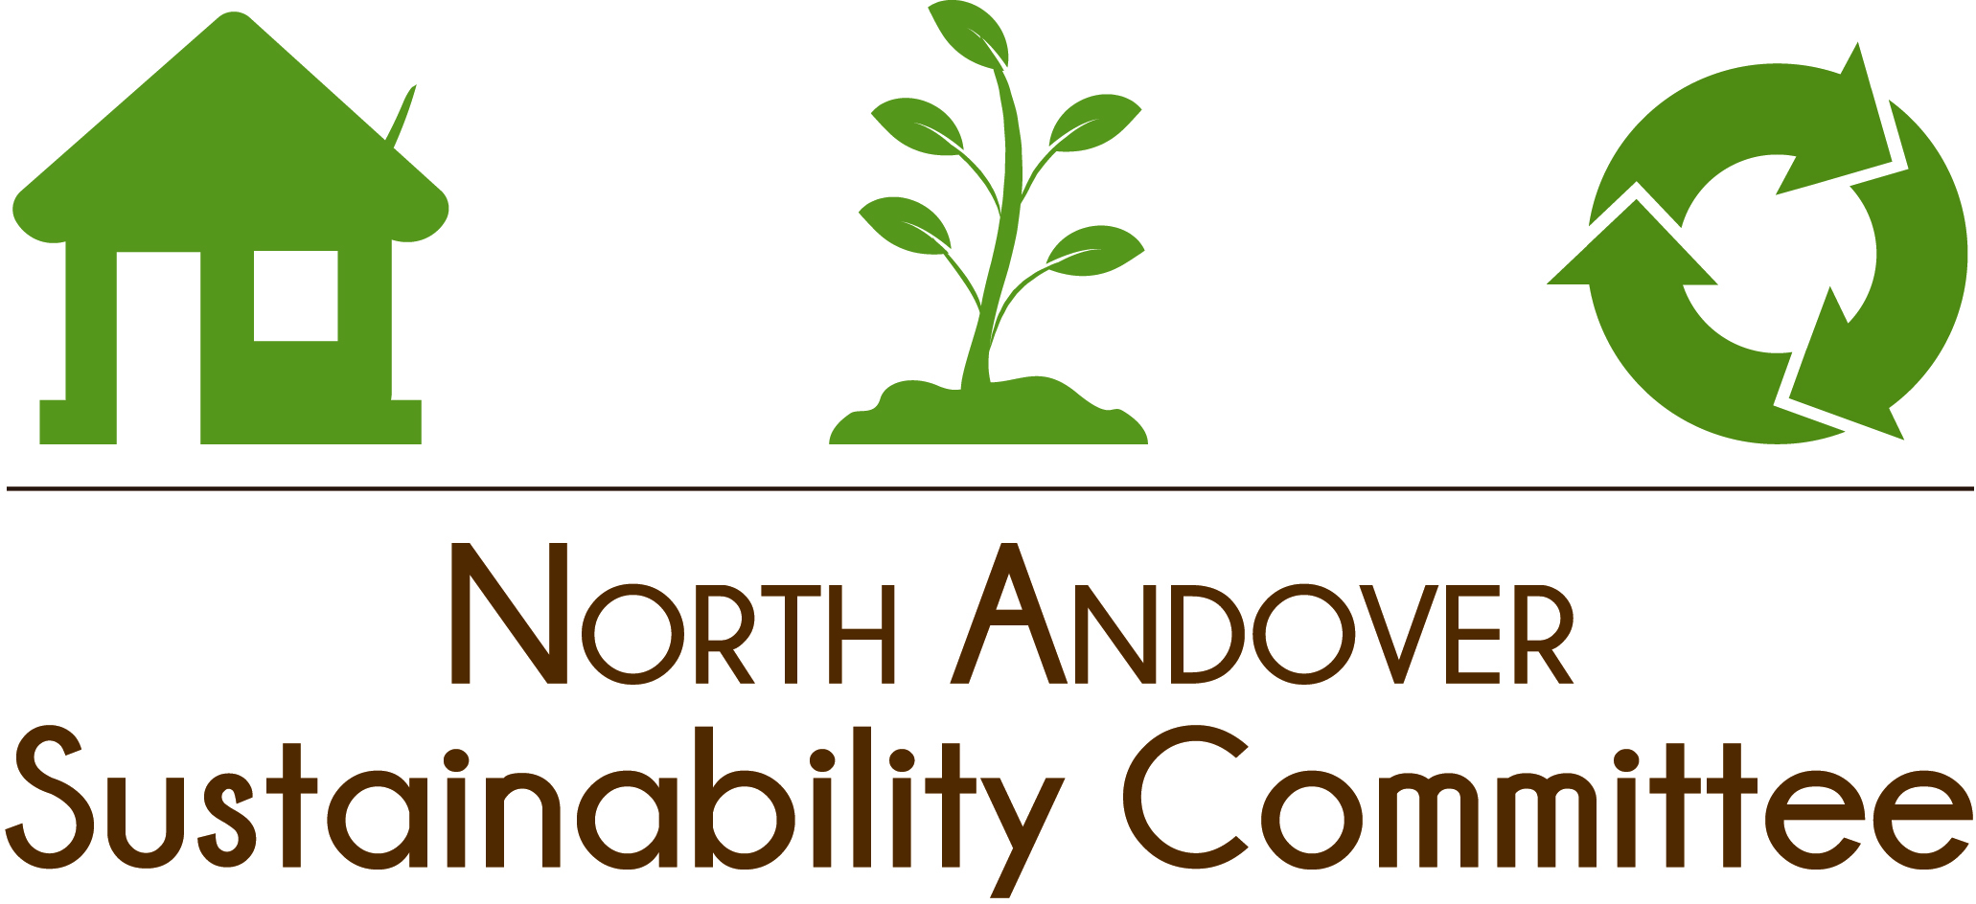
NASC Meeting Agenda

Tuesday, July 18th, 2023, 7:00p

Town Hall – 2nd Floor Conf. Room

Mission
To serve as a resource and advocate for environmental sustainability in our town, focusing on resource conservation, waste reduction, and energy efficiency.

- Call to Order

- Assign meeting scribe: minutes to Christine McElhiney and post in Google Drive

- Take Attendance
  - Introduce New Members and Guests

- Guest - Penny Hill from Bootstrap Compost will present on municipal curbside composting.

- Update on Rain Barrel Program / Compost Bin Sales—do we want to do another promo early fall on rain barrels?

- Green Team Junk Removal Event
  - Host Green Team Event in Fall 2023
  - Determine where we’d like to host the event. Discuss pros/cons of each location.

- Joanna O’Connell – Green Schools Program update

- Textile Recycling – Andy will provide update

- Discuss upcoming events/festivals that we may want to attend/have a booth at.

- Internal/Administrative
  - Upcoming meetings: September 12th

- Adjourn

