MEETING NOTICE
GREATER LAWRENCE TECHNICAL SCHOOL
Town Clerk Date Stamp
Board/Committee Name: GLRVTS District School Committee
Date: Tuesday, November 27, 2018
Time of Meeting: 6:00PM
Location: Greater Lawrence Technical School, Four Winds
57 River Road
Andover, MA 01810
Signature 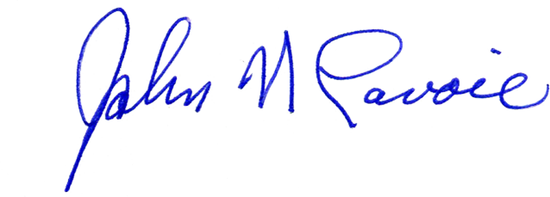

1. CALL TO ORDER
NOTE: The listed matters are those reasonably anticipated by the Chair which may be discussed at the meeting. Not all items listed may in fact be discussed and other items not listed may also be brought up for discussion to the extent permitted by law.

a. Pledge of Allegiance to the Flag
b. Moment of Silence
2. MINUTES
a. Minutes from November 13, 2018
3. FINANCE REPORT
a. Cash Balance Report
b. Consolidated Cash Reconciliation Report
c. Revolving Fund Report
d. Budget Report
4. COMMUNICATIONS
a. Donations
b. Articles
c. Public Participation
5. REPORT OF THE SUPERINTENDENT-DIRECTOR
a. Hot Press Bid for AFFOA
b. Admission’s Report
c. Seacoast RFP for Field
d. Merrimack College RFP for Field
e. Meeting with Executive Director of Licensure
f. Attorney Morris meeting with the Undersecretary of Finance regarding Field Financing
g. Two Year Graduate Data Report
h. Holiday Celebration
6. REPORTS OF COMMITTEES
7. OLD BUSINESS
a. District Committee Priorities
b. Policy
8. NEW BUSINESS
9. PERSONNEL CONSIDERATIONS/REPORT
a. Resignations
b. Leaves of Absence
c. Retirements
d. Appointments
e. Job Postings
10. FUTURE AGENDA ITEMS
11. EXECUTIVE SESSION
a. Pending Litigation, Collective Bargaining, Grievances, Complaints, Student Disciplinary Hearing
12. ADJOURNMENT

